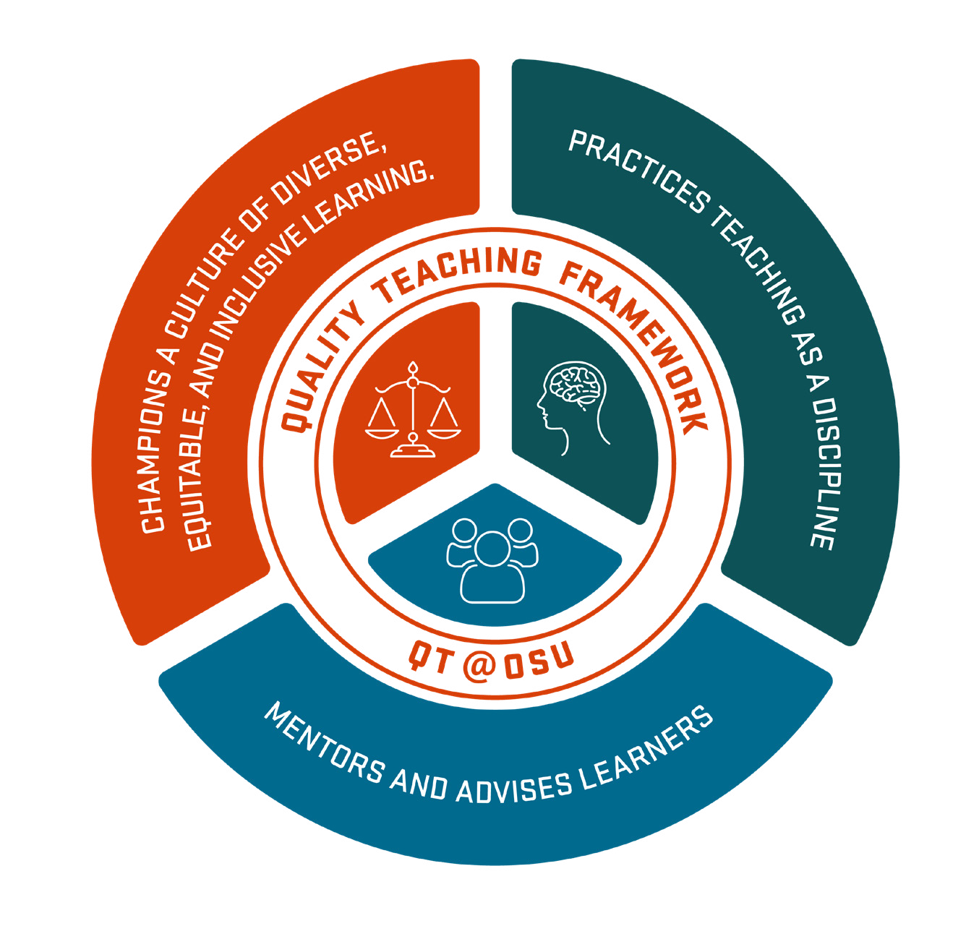
Center for Teaching and Learning

QUALITY TEACHING
FRAMEWORK
OSU faculty are committed to quality teaching and student success. An instructional faculty member engaged in quality teaching is one who:

PRINCIPLE 1 PRINCIPLE 2 PRINCIPLE 3

Champions a culture of diverse, equitable, and inclusive learning.

Practices teaching as a discipline.

Mentors and advises learners.

1.1

1.2
1.3
Recognizes how their own identity influences the learning environment and intersects with broader cultural, social, and political contexts.

Mitigates barriers and provides pathways for learners to achieve full participation.
Builds a sense of belonging and enables collaboration across difference.
2.1
2.2
2.3
2.4
Demonstrates intentional and effective course design.
Demonstrates evidence- based and disciplinary facilitation.
Demonstrates intentional
and effective assessment.
Learns from and contributes to the professional development of teaching.
3.1
3.2
3.3
Supports learners in their
personal growth.
Supports learners in their
professional growth.
Supports learners in their
academic growth.

Ensures each learner has the resources and experiences needed to achieve shared goals.
1.4 2.5

Maintains currency in disciplinary practices and content.
Developed by the OSU Advancement

of Teaching Committee, adopted by the OSU Faculty Senate, 2021

