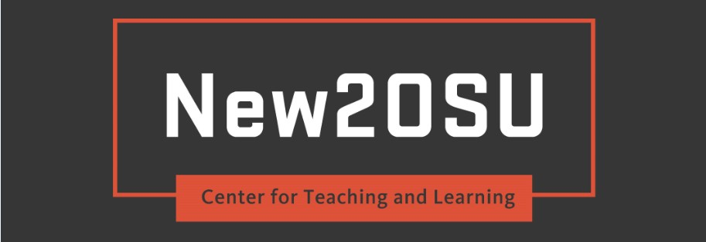

Program Overview
The Center for Teaching and Learning offers teachers the opportunity to earn a Certificate in University Teaching. New2OSU is focused on impacting student success by accelerating the effectiveness of newer teachers. Completion of the program may be used as evidence of professional development and teaching effectiveness for performance review (subject to supervisor approval). This comprehensive certificated program is intended for newer faculty or for those seeking teaching renewal.
At the end of the program participants will have developed the knowledge and skills necessary to build supportive, inclusive, interactive, and instructionally sound learning environments. Through readings, videos, workshops, mentoring, teaching observations, discussions, reflection, and challenging learning tasks, participants learn about and demonstrate effective teaching practices.
New2OSU partners with units across campus when possible and uses a HyFlex synchronous session approach to support the advancement of teaching and use of educational technology. As a Hyflex (hybrid-flexible) program, New2OSU is designed to allow each participant to participate online or face-to-face. As an online participant, all of your assignments and requirements will be fulfilled using various online methods. This will include Canvas, Zoom meetings and various points of contact with the CTL team, New2OSU participants and your RTM. It is your responsibility to create a Zoom account at no cost. You can find information regarding Zoom meetings in the Joining via Zoom! Folder at the following Box link.

Program Expectations
Teachers wishing to pursue certification are asked to commit to a three-term intensive program requiring (on average) 3 hours per week and (on average) 30 hours per term.
Participating in Synchronous Sessions
Preparing for a Synchronous Session
To prepare for a synchronous session, it is important to print out the materials and handouts prior to each session. If you are unsure of where to access specific resources, reach out to the CTL for support. Prior to joining the online Zoom session, be sure your camera and microphone are turned on and working.
During a Synchronous Session
During a synchronous session, it is encouraged that you participate as if you were attending face-to-face. This includes raising your hand, sharing ideas, asking questions and participating in activities (including small break out conversations). When there are multiple participants online, the facilitator will send you into breakout rooms where you can collaborate with other individuals who are online. There are many resources for your use available in these breakout rooms including a chat box and whiteboard.
Term 1 Requirements
Tuesday Teaching + Tech Talks (T4) – Participants attend at minimum 8 out of 11 sessions. It is highly recommended you attend weeks 1, 5, and 11. The workshops are every Tuesday and are facilitated twice in Milam 215 from 10-11:50 a.m. and again at 2-3:50 p.m. To attend the talks virtually, find instructions and materials in Box. This link will provide you access to Zoom in and participate in the teaching and tech talks, access all materials prior to the meeting, and find additional resources relevant to each session.
2019-2020 T4 Schedule
Canvas Academy – The weekly Canvas Academy assignments are a series of activities to guide you through content and assignments designed to provide you with a solid understanding of core Canvas functionality. You will be asked to spend about 30-45 minutes per week. You may be familiar with some of the content already, in which case the tasks will be simple and quick for you to complete. You are still asked to complete these tasks since the assignments build on each other. You are encouraged to ask questions throughout the course and can send an email to canvas@oregonstate.edu.
Campus Connections – Knowing that many OSU students have identified their preference for learning about campus resources from teachers it is important that we know about them so we can teach about them.
For those teaching off-site. For this learning activity, please identify and visit at least 6 different resources at your campus whose missions are to support student success.
For those teaching online. For this learning activity, please identify and visit at least 6 different online resources or resources at your campus whose missions are to support student success.
During your visit, learn about the student and teacher resources and support they provide. After your visit, draft a short reflective response which provides information about these resources as well as ways in which you might leverage and share them with those you teach. At the end of term 1, when you have completed your short responses, please submit them all in one document.
Term 2 Requirements
Individualized Learning Pathways – As you consider where you are in your development as a teacher as well as your needs for moving forward, create your own Individualized Learning Pathway (ILP) to meet those needs. Select and participate in 30 hours of professional development time. After you have completed 30 hours submit a log documenting what you

attended, how long the session(s) were, and how what you learned will impact your teaching and your students' learning. The log is due at the end of the term. For this learning activity, please select ILP options that are hosted either online or are Hyflex. Alternatively, feel free to attend professional teaching development opportunities at your school site and/or by attending conferences, online webinars, etc. You can find Corvallis ILP options on our website.
Term 3 Requirements
Mutual Mentors – This program component is a research-based peer coaching model intended to support the development of Reflective Teaching Mentors (RTMs). In this Mutual Mentoring learning opportunity, you will learn the skills and processes recommended for being a future RTM. To learn and practice these skills you will engage in trios of Mutual Mentors using a Hyflex approach around structured teaching observations and reflective coaching. A portion of Mutual Mentors will include content on the Canvas site and another portion will be spent in synchronous sessions. This work is intended to be mutually empowering, supportive, formative, and non-evaluative. It is also designed using a socio-cultural and constructivist approach so your participation and maintaining pace is imperative to co-construct our understanding of how we play a critical role in the creation of reflective mentors that can support the development of teaching practices.
For those teaching off-site. For this learning activity, when possible, you will be partnered with colleagues from your school site. Alternatively, you may be partnered with colleagues who either teach online or at a different location. In these cases, alternative access to teaching (i.e. recorded videos or Zoom sessions) will need to be shared.
For those teaching online. For this learning activity, when possible, you will be partnered with colleagues who also teach online. In this case, alternative approaches should be considered (i.e. review of course content via the Quality Matters rubric).
Terms 1-3 Requirements
Portfolio Creation – Throughout the year you are asked to draft and revisit your teaching philosophy and continue to assemble and revisit a portfolio. Throughout the year you should solicit feedback from CTL, your mentor, your students, and each other. While we have intentional learning activities to prompt you we suggest you find additional opportunities to collaborate. At the end of the year you will be asked to showcase your portfolio to your peers; to submit your portfolio to CTL as your culminating project; and you will be asked to forward it to your department head as part of your annual review.
Reflective Teaching Mentor – New2OSU is intended to be learner-driven in which participants are provided opportunities to drive their own learning. Based on your desired learning needs and goals, you will be paired with a cross-disciplinary RTM. While a list of recommended activities provides some structure, it is also intended to be flexible to meet your personalized needs. Together with your mentor we ask you to complete the activities but be flexible. Adjust the activities so they are authentic and relevant to your goals. These activities may be done in any order and at any time throughout the three terms of your participation in New2OSU.

*As an online New2OSU participant, your relationship with your RTM will be structured around online meetings and communication. It is encouraged to think about that when selecting and designing your mentoring relationship.
Cohort Collaborative Hubs (Optional) – Previous participants have valued the personal relationships established during New2OSU. We hope you too will consider “meeting” to connect. For those teaching off-site we hope you can make cohort connections on your campus. And for those teaching online we hope you can connect virtually.

For questions or for more information, please contact Brooke A. Howland, Ed.D.

